*Software Requirement Specification*

*For*

*Digital Voting System*

Table of Contents

Table of Contents ii

Revision History ii

1. Introduction 1

1.1 Purpose 1

1.2 Project Scope and Product Features

2. Overall Description 1

2.1 Product Perspective 1

2.2 User Classes and Characteristics 1

3. System Features 2

3.1 Information about Voting…………………………………………………………………………..

3.2 Notifications for other votings……………………………………………………………………...

3.3 Knowing winners of voting………………………………………………………………………..

3.4 History of Voter……………………………………………………………………………………………….............................

4. External Interface Requirements 6

4.1 User Interfaces 6

4.2 Hardware Interfaces 7

4.3 Software Interfaces 7

4.4 Communications Interfaces 7

5. Other Nonfunctional Requirements 7

5.1 Performance Requirements 7

5.2 Safety Requirements 8

5.3 Security Requirements 8

5.4 Software Quality Attributes 8

# Introduction

## Purpose

This SRS describes the software functional and nonfunctional requirements for digital voting system. It is used to **verify** the functions of the digital voting system. The purpose of this system is to implement the computerization of the details, Polling results, current Polling and candidates .This allows students to login and be authenticated as an entitled voter for election purposes. The digital voting System is recognized as secure and accurate in its ability to authenticate voting results.

## Project Scope

* Less effort and less labor intensive, as the primary cost and focus primary on creating, managing, and running a secure web voting portal. Increasing number of voters as individuals will find it easier and more convenient to vote, especially those abroad. This system has secured login procedure. Knowing nominees with respective wards.Casting vote is possible only with successful authentication of voter

# Overall Description

## Product Perspective

The Digital Voting System is a new system that replaces the current manual and paper based process of voting system. The E-R diagram in figure illustrates the external entities and system interfaces for e-voting system.

## User Classes and Characteristics

* **Voter :**  Voter is one person, who can use this voting system. It plays key role in this System. He will get features of this system through mobile application. He has unique voter id and for this system.In this user who is above 18 year’s register his/her information on the database and when he/she want to vote he/she has to login by his Adhaar ID and fingerprint authentication and can vote to any party only single time. He should aware of using mobile.
* **Nominee:** Nominee are persons who participating in election. They can show to all Voter through this system. Voter can vote any one of the Nominee. One of the nominee may for that election. He has one party and symbol. He should have qualification to participate in voting.

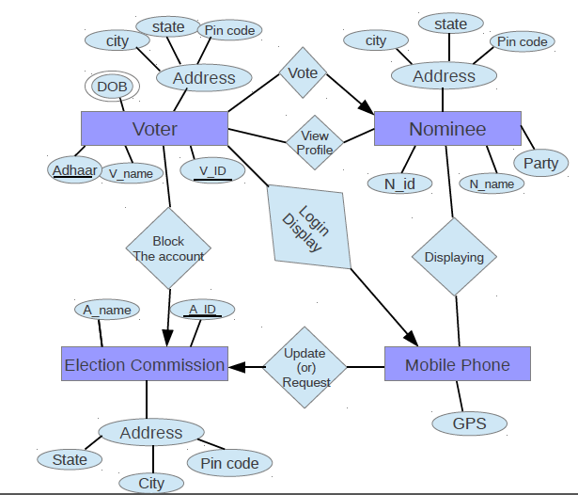

* **Election Commission :** The election commission is main part in this System. The election commission conduct elections for all categories . It has all rights of both election and voter. It can get information from other institutions and create election for that institution in certain time. Registration of voter is done by the system administrators for security reasons.
* **Mobile :** It is the interface between the Election Commission and Voter. It can support to this system. It has portability. It can give information about the voter from where he voted.

# System Features

## Information about Voting

In “DIGITAL VOTING SYSTEM” a voter can use his\her voting right online without any difficulty. The system Administrator registers the voters on a special site of the system visited by him only by simply filling a registration form to register voter. Citizens seeking registration are expected to contact the system administrator to submit their details. After the validity of them being citizens of India has been confirmed by the system administrator by comparing their details submitted with those in existing databases such as those as the Registrar of Persons, the citizen is then registered as a voter.

## Notification for Voting.

This “DIGITAL VOTING SYSTEM” gives notifications to all the voters about the election . The notifications so many types. Voter can get notification for every action taken by Election commission. The notification gives the timing of election to voters.

## 3.3 Information about winners

It gives the information about the winner of every elections and it updates voter knowledge about the elections and the leaders.

## 3.4 History of Voting for voter

Voter can know the information about past voting he participated .

# External Interface Requirements

## User Interfaces

UI-1: The Mobile app which contain the best user interface which implemented by

XML and some Android graphics.

UI-2: For the Election commission the user face contains the website which implemented by HTML,CSS,JAVASCRIPT,PHP.

## Hardware Interfaces

1. For the voter the hardware requirement is smart phone.
2. For Election commission the hardware requirement is laptop or computer.

## Software Interfaces

1. For creating Android app we are using ANDOIRD STUDIO 2.2.3
2. For creating Web for Election commission we are using Geany.
3. For maintaining the database and server we are using XAMPP .

## Communications Interfaces

1. For communication we are using Internet.
2. For communicate the mobile and web we are using PHP and FIREBASE.

# Other Nonfunctional Requirements

## Performance Requirements

1. Provision of improved voting services to the voters through fast, timely and convenient voting.
2. This system is a lot easier to independently moderate the elections and subsequently reinforce its transparency and fairness.
3. It can work efficiently with any number users can use. Everyone can use this system.

## Safety Requirements

1) Voting can be done without Rigging.

2) No one cannot see how the people vote for someone.(vote is encrypted).

3) The design implementation and testing procedures must be well documented.so that the voter

Confidence in the election process is ensured.

## Security Requirements

1. No one should be able to determine how any individual voted.
2. The administrative authority shall rest with single entity. The authority always check the system.
3. The system should be designed to extremely simple, as complexity to disturb the system .

## Software Quality Attributes

Availability: The Digital Voting System shall be available to users on the corporate Internet in election times in other times it provides information about results and further elections.